

Tshwane University of Technology

Faculty of Information and Communication Technology

**Department of**

**Computer Systems Engineering**

**Bi-Directional Conveyor Belt Metal Detector with Start & Stop Button**

**PLC216D**

**AIMS & OBJECTIVES**

**AIM:** To collect the mixed materials and filter out metal(copper) using the conveyor belt using a metal detector sensor and push buttons in a PLC module that powers the motor of the belt.

**OBJECTIVES:** Detect the metallic components from the collected mix and sort them from the plastic materials. This will be done by the using the conveyor belt and changing its direction frequently to get the metallic components in one basket with no plastic materials. When the “START” push button is pressed, the SN04-N Sensor detects a metal(copper) in the conveyor belt, the red LED will switch on and the motor will reverse and the metal will be put inside the metal basket, and when the SN04-N Sensor detects a plastic the green LED switch on and the motor will continue moving forward and the plastic will be put inside the plastic basket. When the “STOP” push button is pressed both LEDs switch off and the motor stops leading to the process halt immediately.

**COMPONENTS**

* Breadboard
* Wires
* Motor
* PLC Module & Power Supply
* Red LED
* Green LED
* Conveyor Belt
* Push button Switches
* SN04-N Sensor
* Resistors (Voltage Divider Circuit)
* H BRIDGE (DIRECTION CHANGE)

**METAL DETECTOR SENSOR**

The SN04-N is an inductive proximity sensor which is used as an indicator of position or

proximity of ferrous or metallic materials. It can be an excellent support in the design of

sumo robots to detect the opponent, as well as in processes where it is required to count or

detect metallic or ferrous objects. When the SN04-N is close to a metallic object, its output

sends a control signal in addition to having a status indicator LED which visually supports us

in the detection. It can also be used as a turn counter in a gear or metal wheel.

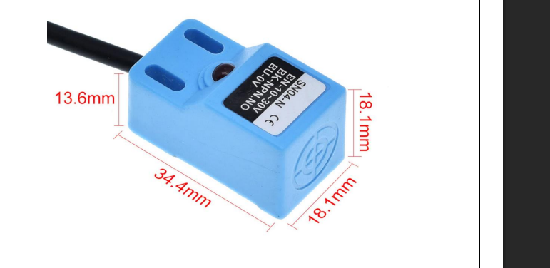

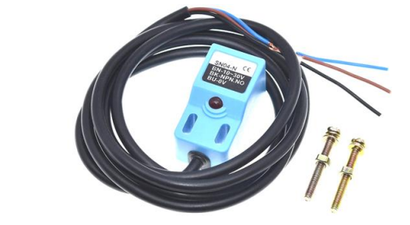

**PROCEDURE**

1. **Design Phase**

Step 1: System Requirements Analysis

* Inputs needed: Start, Stop, Metal detection
* Outputs needed: Motor forward/reverse, Status LEDs
* Safety: Emergency stop functionality

Step 2: Circuit Design

* Create block diagram of complete system
* Specify all components (PLC, sensor, motor driver, etc.)
* Design wiring schematic
* Voltage Divider circuits were implemented to drop 24v to 5v

1. **Software Development**

Step 3: PLC Fiddle Prototyping

* Develop initial ladder logic in PLC Fiddle online
* Test virtual simulation
* Refine logic based on simulation results

Step 4: TIA Portal Implementation

* Transfer ladder logic from PLC Fiddle to TIA Portal V12
* Configure hardware (S7-1200 PLC)
* Set up I/O addressing matching physical wiring

1. **Implementation Phase**

Step 5: Hardware Setup

* Mount all components on board
* Wire power supply connections
* Connect input devices (buttons, sensor)
* Connect output devices (motor driver, LEDs)

Step 6: Programming

* Compile ladder logic in TIA Portal
* Download program to physical PLC
* Verify no compilation errors

1. **Testing & Validation**

Step 7: Functional Testing

* Test Start/Stop functionality
* Verify sensor detection works
* Check motor direction changes
* Confirm LED indicator’s function

Step 8: System Integration

* Test complete automated sequence
* Validate metal/plastic sorting
* Measure response times
* Document any issues found

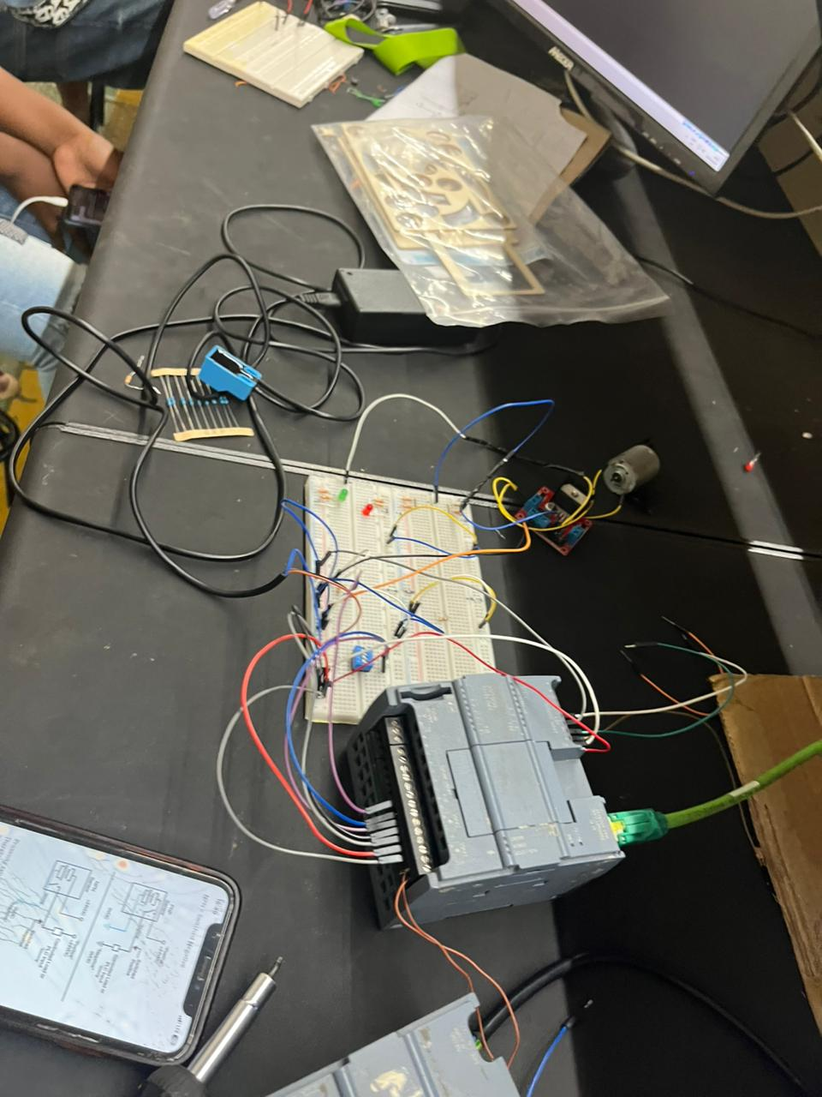

**CONVEYER BELT**

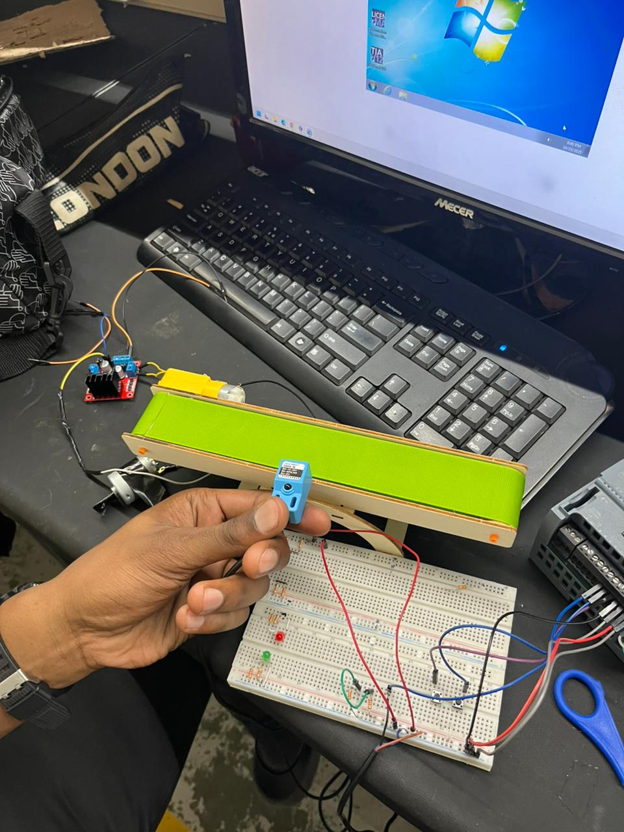

An easy to assemble conveyer belt was used to archive the above structure.

**LADDER ON PLC FIDDLE**

**PLC 1211C - SIMATIC S7-1200**

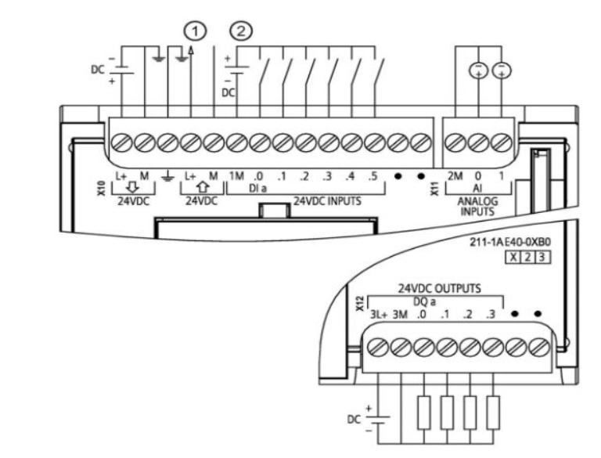

**VOLTAGE DIVIDER FOR OUR DRIVER AND LEDS**

**CODE IMPLEMENTATION**

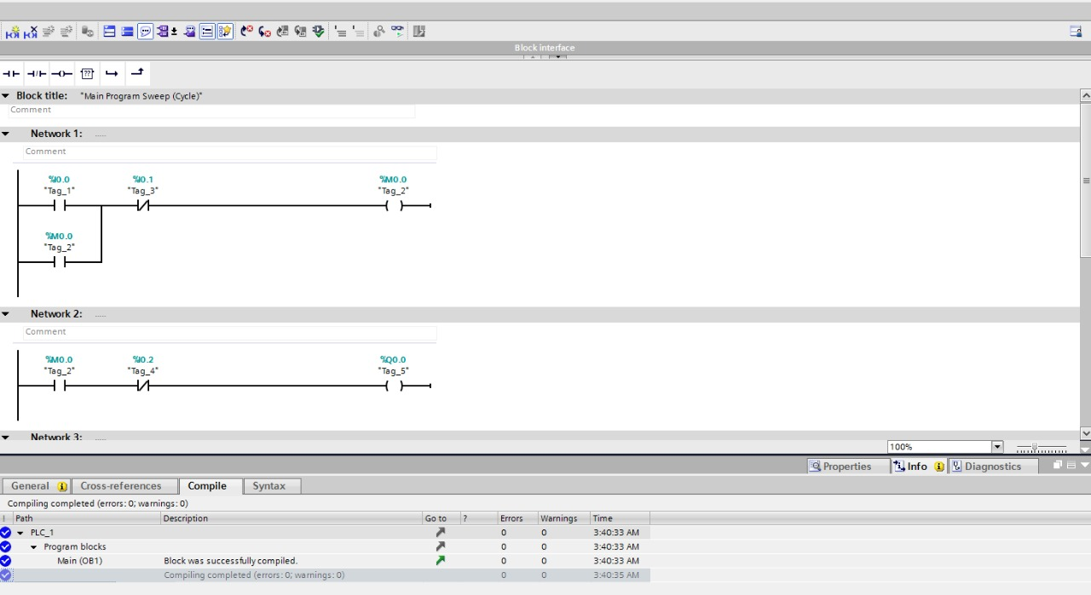

**CONCLUSION**

The bi-directional conveyor belt operates correctly using the PLC as the controller. The push button starts the whole conveyer belt movement and moves forward, the metal NPN sensor will detect metal on the conveyer belt and reverse the belt and trashes the metal found.